Javascript Lab

Quiz loading first question

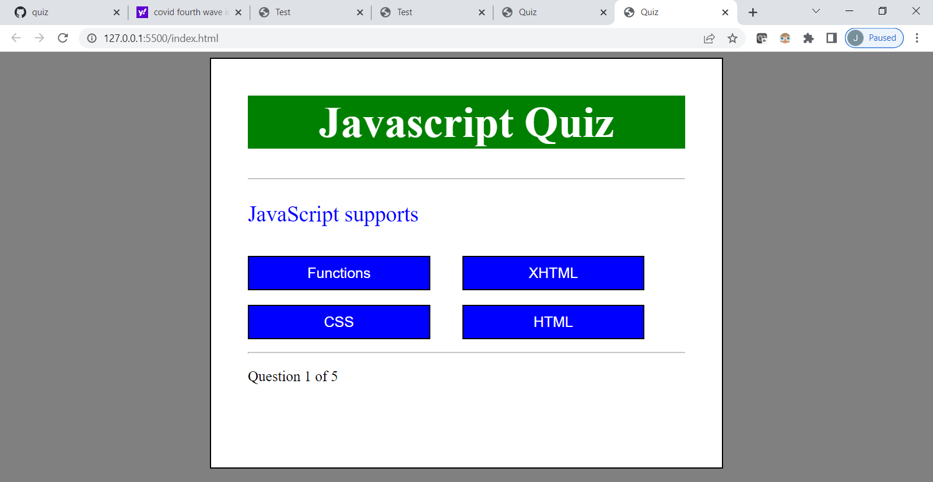

After answering , it moves to next question

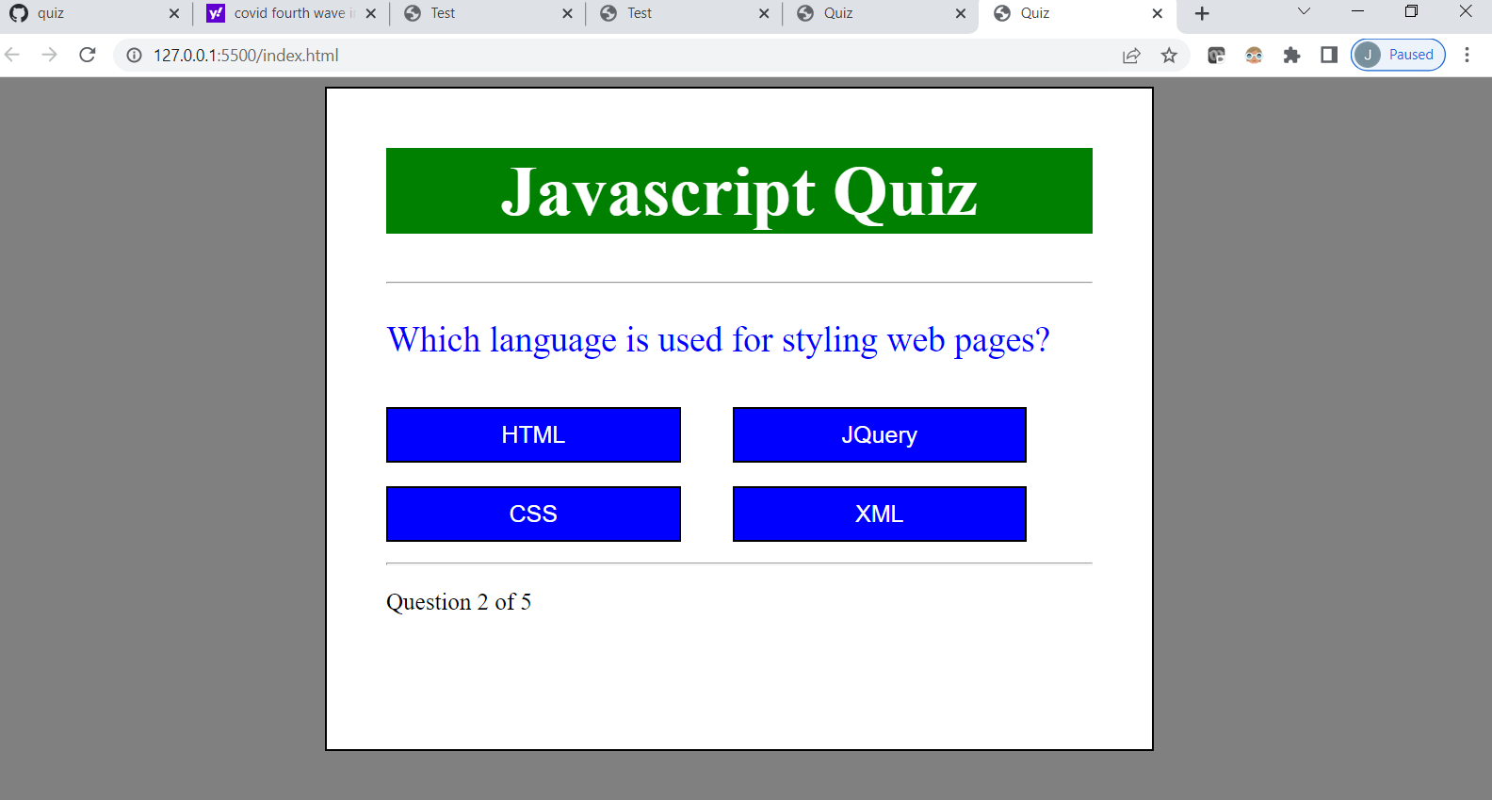

Progress is shown in below.

After completing all 5 question

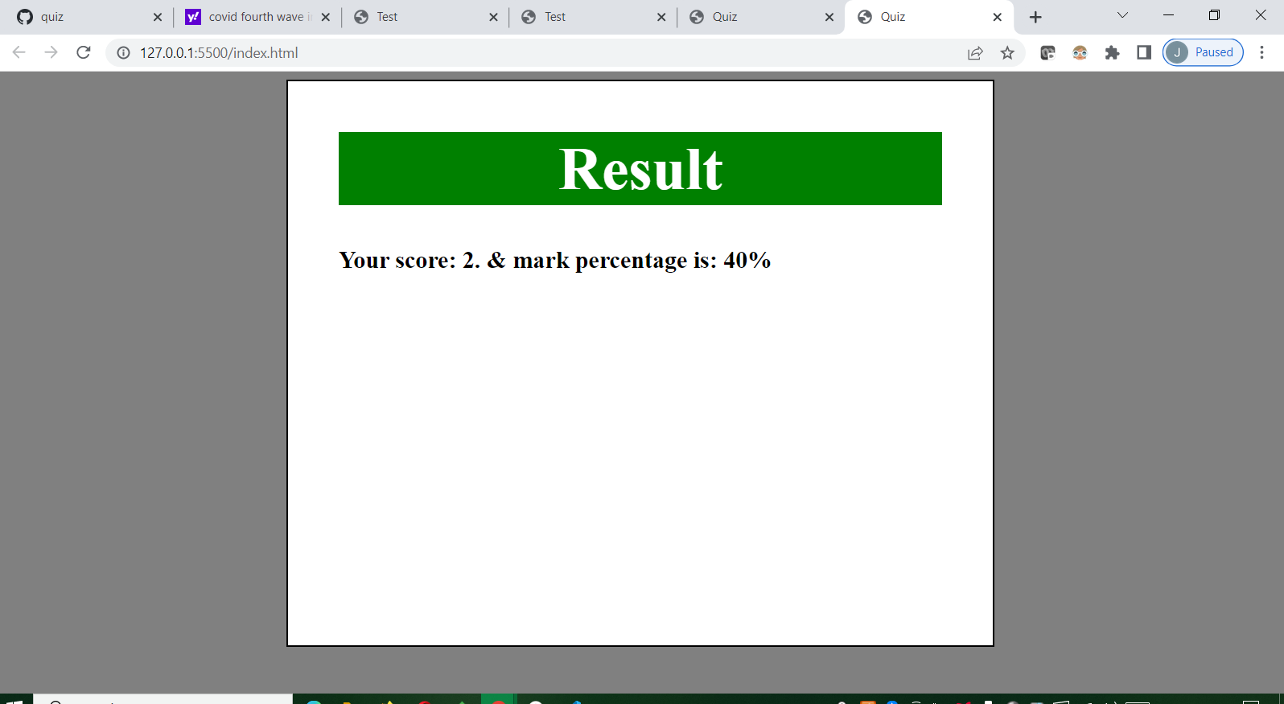

Score and result is displayed In percentage.